1. File Transfer Protocol
   1. Description of Existing Application

FTP Client requests FTP Server for a list of available files and then sends a file download request to the server. The server sends the requested file in small chunks to the client.

* 1. Design Enhancements

This overall functionality is similar to that of initial application description. Figure 1 shows an overview of the current architecture for this system where as the UML Sequence Diagram in Figure 2 shows this client-server interaction in more details. However this version has following changes:

* FileTransferAck message will be removed. Hence client will not inform the server about successful transfer of file. After sending the last chunk of data, the Server will terminate itself.

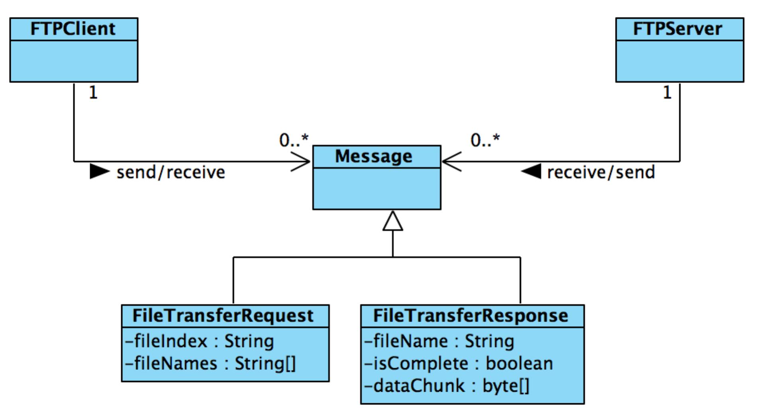

Figure 1: Architecture Diagram for FTP

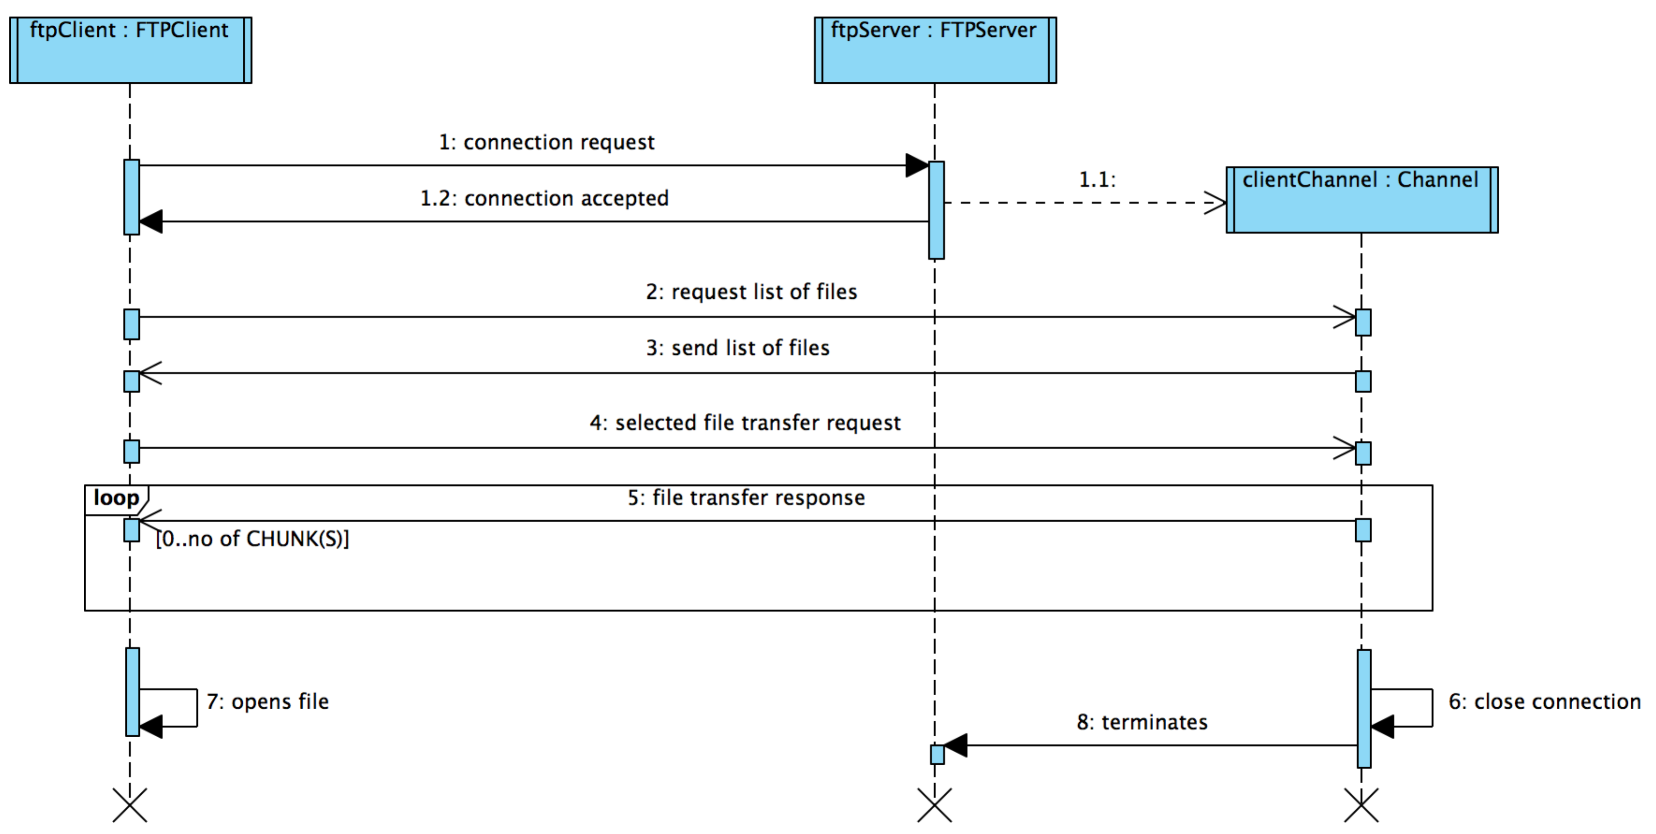

Figure 2: Interaction diagram between *FTPClient* and *FTPServer*